**Investigating different factors (Chain Length/Branching, number and location of double bonds and molar mass) that affect the Boiling Point of Hydrocarbons**

**Chemistry Internal Assessment**

Arsh Mobeen

SNC4MC-02

Mr.Wilson

2022-10-15

**Introduction**

This Internal Assessment has investigated different factors that impact the boiling point of alkenes and alkanes. Individually these factors, including Chain Length/Branching, the number of Double Bonds and Molar Mass will be analyzed, determining the differences in the magnitude of impact these factors have on the boiling points of both Alkanes and Alkenes. In this IA, the molar mass of compounds have been primarily used to determine the pattern that an increasing number of Carbons and Hydrogens may have upon the boiling point. A line of regression has aided in determining the approximate increase in boiling point per each extra carbon and hydrogen bond. These values are then compared to the results that we obtain when the other variables, including Chain Length, Branching as well as the number and location of double bonds, are graphed against boiling points. This in turn allowed us to determine the resultant impacts that different variables have on boiling points, providing us with material to base our analysis of the differences between Alkanes and Alkenes. At the end, the results are linked back to society, and the purposes of both Alkanes and Alkenes in society are discussed. This IA was based on a database, and steps to collect the most reliable data were taken, although some exceptions do exist, which have been indicated when applicable. The following databases were used.

* http://www.chemspider.com[/](http://www.chemspider.com/) **(Main)**
* [https://www.aatbio.com/tools/predictive-modeling/boiling-point-predicto](https://www.aatbio.com/tools/predictive-modeling/boiling-point-predictor)r

For this IA, the following hydrocarbons will be observed (differentiating them with double bonds and chains later):

* Ethane/Ethene
* Propane/Propene
* Butane/Butene
* Pentane/Pentene
* Hexane/Hexene
* Heptane/Heptene
* Octane/Octene
* Nonane/Nonene
* Decane/Decene

Hydrocarbons are organic compounds that consist entirely of hydrogen and carbons, and are the focus of this internal assessment. [1]They serve as primary components of natural gas and petroleum, but are also important to the manufacturing of rubbers, solvents, explosives, plastics, and industrial chemicals.[2] Many times, especially within a mechanical machine such as engines, the temperature within can heat up to extremely high levels, which is why the knowledge of boiling point is very important. The boiling point of a substance is the temperature where the vapor pressure of a liquid is equal to the pressure surrounding the liquid, often the standard sea level atmospheric pressure.[3] This causes a change of state from a liquid to a gas, where the energized molecules change to a gas and rise into the atmosphere while forming bubbles. Like the other property, melting point, a higher boiling point indicates greater intermolecular forces within the molecule, since more energy was required to boil the substance. This in turn allows us to determine the substances that may be more resilient under pressure. Below, data tables taken from reputable databases compare the boiling points of Alkanes and Alkenes, organized by molar mass and made complex through the implementation of chains and double bonds. These values will help in determining the different molecular features of hydrocarbons that may make a molecular weaker or stronger.

**Personal Engagement**

Chain length/Branching is a part of organic chemistry, knowledge that is mostly new to me, so by picking this as my IA topic, I wish to broaden my knowledge of chemistry as a whole. I am also looking at alkenes, which like alkanes are part of compounds that we haven't looked at too much at this stage in HL chemistry. This IA will also aim to relate the derived information back to society, by taking a look at the purposes that alkanes and alkanes may have in terms of the engineering and manufacturing of materials that we use on a daily basis.

**Research Questions**

Investigating different factors (Chain Length/Branching, number and location of double bonds and molar mass in g/mol) that affect the Boiling Point (℃) of Hydrocarbons

**Hypothesis**

If the general number of Carbon and Hydrogen atoms increases, then so will the boiling point, because of the presence of greater intermolecular forces.

**Variables**

|  |  |  |
| --- | --- | --- |
| **Independent Variables** | **Dependant Variables** | **Control Variables** |
| * Chain Length/Branching (unitless) * # of Double Bonds (unitless) * Location of Double Bonds (unitless) * **Molar Mass (g/mol)** | * Boiling Point (℃) | * The Source of Data   The main concern for the source of data is making sure that the two variables, Boiling Point and Molar Mass will both be taken from the same database, to ensure that their methods remain consistent. However, multiple sources will be used to compare and contrast databases. This is where this becomes essential, since in case of a difference between two data sources, we can compare and contrast their methods. In the end, the most reliable and informative database was chosen. |

**Materials**

* 1x Beaker (mL) - Uncertainty of 10 mL
* 1x Beaker Stand
* 1x Bunsen Burner
* Gloves, Lab Coat, Classes
* Striker
* Liquid hydrocarbon
* Thermometer (°C) - Uncertainty of 0.5°C

**Safety Considerations**

Please note, this section was written in the case that the experiment was conducted in a lab, although the IA’s material is taken from a database. In this case, the two variables that we would have to experimentally measure are the molar mass and boiling point, so for these we would do separate methods. Before the experiments however, we would need to obtain our compounds themselves. Considering that we were able to obtain them, and they require their own safeties, which after research I have discovered are almost all the same for these 10 alkenes and alkanes.

* + They can affect you when breathed in
  + Skin contact with liquid alkenes can cause frostbite.
  + Exposure to alkenes can cause headache, dizziness, fatigue, lightheadedness, confusion and unconsciousness.
  + Highly Flammable
  + Reactive
  + Dangerous Fire and Explosion Hazards[4]

**Method**

1. Put on a lab coat, gloves and goggles and retrieve the materials listed above
2. In the beaker, carefully pour out the liquid hydrocarbon, starting from ethane
3. Place the beaker on the beaker stand
4. Light the bunsen burner with a striker
5. Place the bunsen burner underneath the stand
6. Wait until bubbles being to frequently form on the surface of the liquid
7. Place the tip of the thermometer 10 cm below the surface of the liquid
8. After 30 seconds, remove the thermometer and note the temperature for the given liquid
9. Safely dispose of the liquid hydrocarbon
10. Repeat steps 2-9 for the rest of the alkenes and alkanes
11. Clean and return the materials used and remove safety equipment

For the data tables expressed below, an uncertainty of ± 3.0 °C was utilized for all values as explained by the database chemspider.com, in which they have listed an approximate 3.0 uncertainty for their boiling points. Although they do not state where the uncertainty came from, we can certainly assume the presence of a thermometer and beakers being used during the experiment, thus a possible area of uncertainty. Please note that for almost 5 values in the last table, the uncertainty was ± 40 °C instead since a different resource was used. As well, sample calculations for both the molar mass and boiling point will be given. However, the boiling point was taken from databases that do not reveal their methodologies for calculation, so the sample calculations for boiling point are done by myself incorporating advanced topics and do not serve as data.

**Boiling Points of Different Alkanes**

|  |  |  |
| --- | --- | --- |
| **Alkane Chemical Name** | **Molar Mass (g/mol)** | **Boiling Point( ± 3.00 °C)** |
| **Ethane** | 30.08 | -89.0 |
| **Propane** | 44.09 | -42.0 |
| **Butane** | 58.12 | -1.00 |
| **Pentane** | 72.15 | 36.0 |
| **Hexane** | 86.17 | 69.0 |
| **Heptane** | 100.2 | 98.0 |
| **Octane** | 114.2 | 126 |
| **Nonane** | 128.3 | 151 |
| **Decane** | 142.3 | 174 |

**Sample Calculations (Molar Mass)**

Eg. Ethane - C2H6

Mass (Carbon) = 12.01

Mass (Hydrogen) = 1.01

**Sample Calculations (Boiling Point)**

Eg. Ethane - (∆G = 0 since that is the minimum point for spontaneous vaporization)

Rearranging: →

Alkanes are a type of hydrocarbon that consist of only Carbon and Hydrogen single bonds.[5] Below is an example of Ethane, an alkane that consists of 2 Carbons and 6 hydrogens as given by its chemical name.

C

H

C

H

H

H

H

H

From the table and graph, we can visually see the predicted hypothesis that as molar mass increases, so will the boiling point. The increasing molar mass comes from the presence of extra Carbon and Hydrogens as the bonded chain increases, creating more intermolecular forces that have to be overcome in order to reach the boiling temperature.

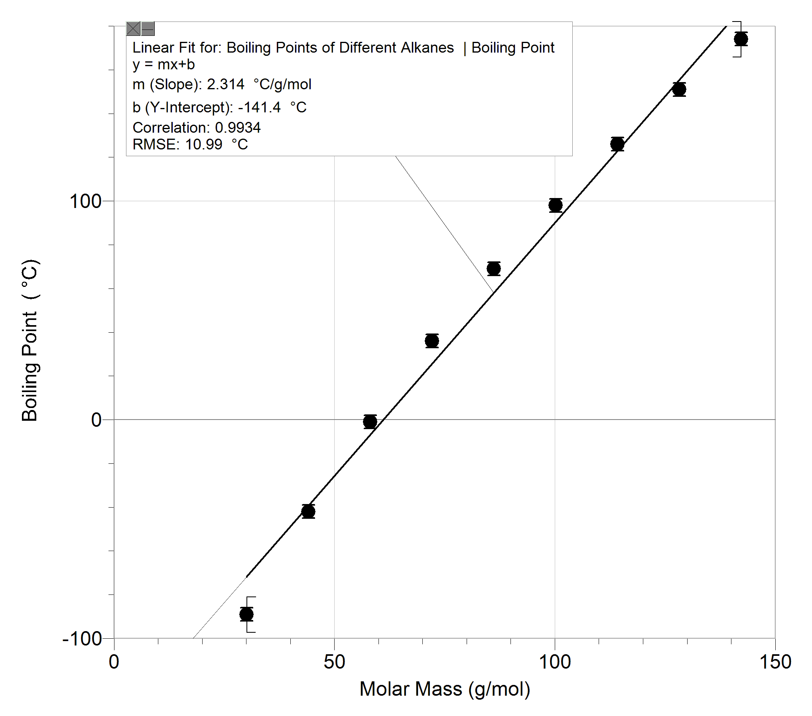

**Boiling Points of Different Alkanes**

**Boiling Points of Different Alkenes**

|  |  |  |
| --- | --- | --- |
| **Alkene Chemical Name** | **Molar Mass (g/mol)** | **Boiling Point( ± 3.0 °C)** |
| **Ethene** | 28.06 | -104 |
| **Propene** | 42.08 | -48 |
| **Butene** | 56.11 | -6 |
| **Pentene** | 70.13 | 29.9 |
| **Hexene** | 84.16 | 63 |
| **Heptene** | 98.19 | 93.6 |
| **Octene** | 112.21 | 123 |
| **Nonene** | 126.24 | 146.9 |
| **Decene** | 140.27 | 172 |

Sample Calculations (Molar Mass)

Eg. Ethene - C2H4

Mass (Carbon) = 12.01

Mass (Hydrogen) = 1.01

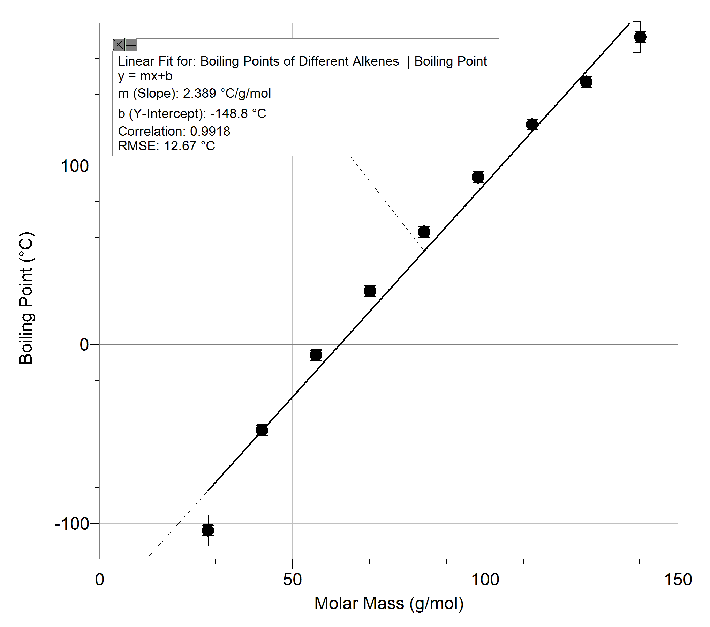

**Boiling Points of Different Alkenes**

Alkenes are a type of hydrocarbon that consist of only Carbon and Hydrogen atoms, but have at least 1 double bond in them chain. The sigma and pi bonds in a double bond make it stronger than a single bond. The table above states values taken from alkenes whose double bonds are all in the first position in the chain (Alk-1-ene). Below is an example of Ethene, an alkene that consists of 2 Carbons and 4 hydrogens as given by its chemical name.

C

H

C

H

H

H

The values in the table follow the same trend as the alkanes; as molar mass increases, so does the boiling point. However, the molar mass of all alkenes in the table are lower than their respective alkanes, due to the presence of a double bond between carbons. Carbons are only able to accept 4 electrons in their already 4 electron filled valence shell, and hydrogen atoms, with one electron each, fit perfectly. However, when a double bond is created between carbon atoms, they share 4 electrons while they previously shared only 2 as an alkane. Due to this, both of the carbons no longer have space for a third hydrogen atom, creating an Index of Hydrogen Deficiency of 1 and losing two shielding hydrogen atoms overall, causing the molar mass to be lower. However, the boiling points, although similar, are also smaller than their alkane counterparts, which can be sourced back to how their London Dispersion intermolecular forces (LDFs) are lower than Alkanes. Out of the three types of intermolecular forces (LDFs, dipole-dipole and hydrogen bonding), simple alkanes and alkenes only have London Dispersion forces since they are nonpolar.[6] This type of force arises from temporary polarities that are created across a molecule due to the orbits of electrons and so are directly proportional to the number of electrons in a molecule. Alkenes have an IHD of 1, and so two less hydrogen atoms, resulting in a lower London dispersion force, and thus a lower boiling point. So we can conclude that, although the difference wasn’t by much, the lack of hydrogens in alkenes make them slightly weaker and easier to boil than alkanes.

Now, we can take a look at the impacts that changing the double bond location can have on boiling point for alkenes.

**Boiling point of alkenes with 2nd Double Bonding Position**

| **Alkene Chemical Name** | **Molar Mass (g/mol)** | **Boiling Point( ± 3.0 °C)** |
| --- | --- | --- |
| **But-2-ene** | 56.12 | 0.9 |
| **Pent-2-ene** | 70.13 | 36 |
| **Hex-2-ene** | 84.16 | 67 |
| **Hex-3-ene** | 84.16 | 68 |
| **Hept-2-ene** | 98.19 | 98.5 |
| **Hept-3-ene** | 98.19 | 96 |
| **Oct-2-ene** | 112.21 | 125.4 |
| **Oct-3-ene** | 112.21 | 120 |
| **Oct-4-ene** | 112.21 | 129 |
| **Non-2-ene** | 126.24 | 150 |
| **Non-3-ene** | 126.24 | 145 |
| **Non-4-ene** | 126.24 | 146 |
| **Dec-2-ene** | 140.27 | 173 |
| **Dec-3-ene** | 140.27 | 171 |
| **Dec-4-ene** | 140.27 | 171 |
| **Dec-5-ene** | 140.27 | 172 |

Sample Calculations (Molar Mass)

Eg. But-2-ene - C4H8

Mass (Carbon) = 12.01

Mass (Hydrogen) = 1.01

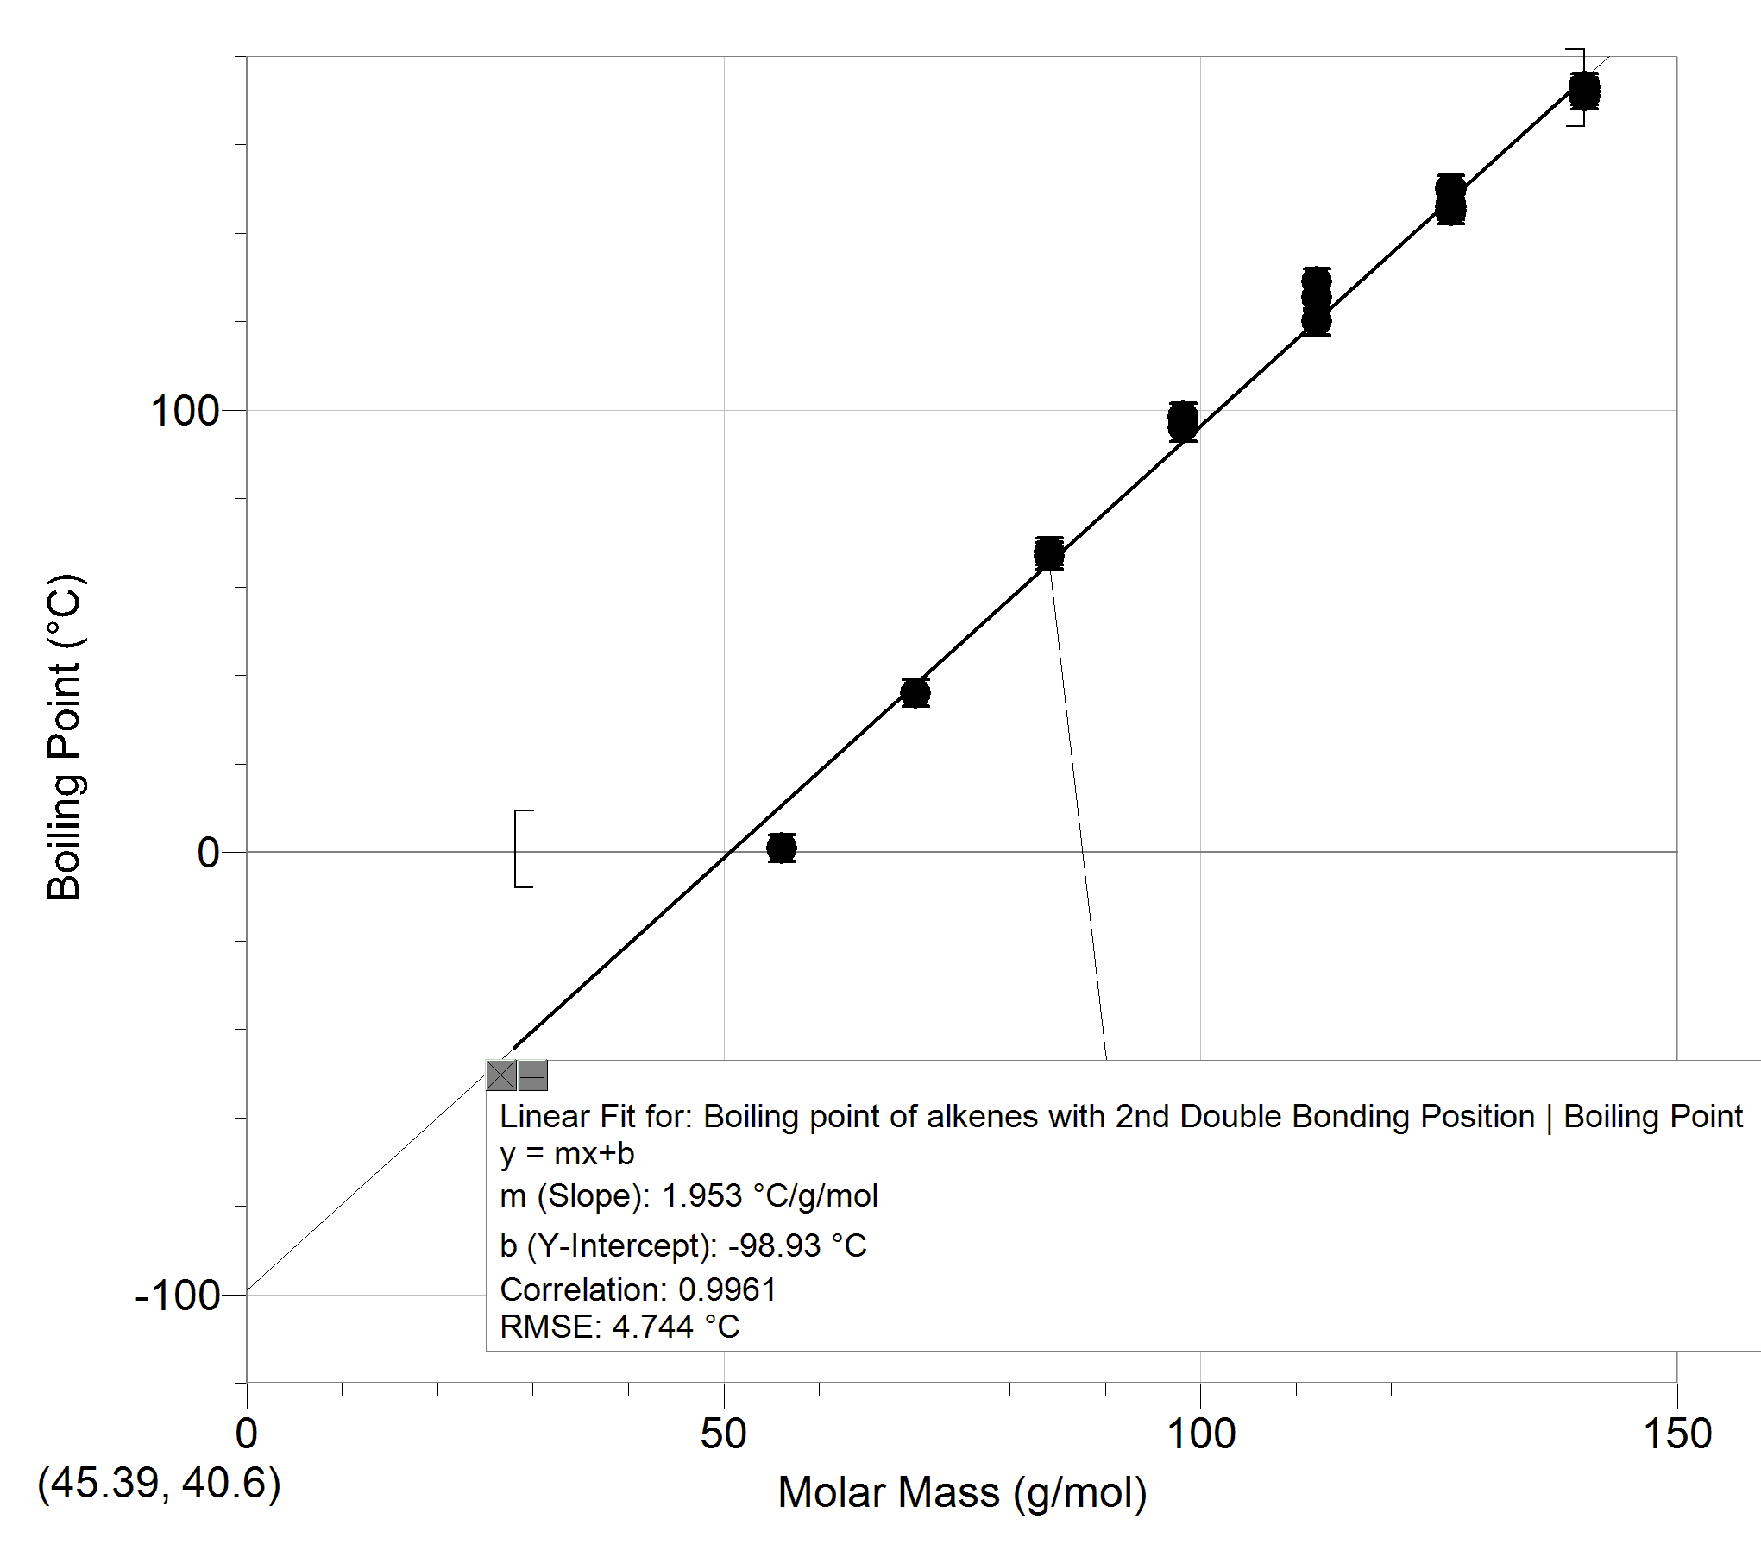

**Boiling point of alkenes with 2nd Double Bonding Position**

From this data, we can observe a multitude of trends. Firstly, the boiling points of these compounds have now often become slightly higher than the boiling points of alkenes in the table above, when all that was done was changing the location of the double bonds within alkenes. Now the table for alkenes above had the double bond placed on the first carbon-carbon bond on the chain, so structure wise, the double bonds here were located closer to the center of the chain. The differences in boiling point were not that great, so one possibility for the difference could be due to the extra shielding for the double bond when its location is changed to a more central one. The single bonded carbon and hydrogen bonds on the outer parts of the chain serve as shielding for the stronger double bond. However, one curious implication of our data is how for nonene and decene, as the double bonds become more central, the boiling point drops by a few degrees, but mostly, the boiling point rises by a few degrees when the location of the double bonds are changed and made more central.

Now, in order to strictly look at the number of double bonds in a hydrocarbon, we can consider diene’s for each of our alkenes starting from propene. Note, the most reliable information was taken for this table, meaning that the locations of the additional double bond does vary. Considering this, the table below aims to only explain the importance of a second double bond on the boiling point.

**Boiling point of Alkenes with two double bonds**

|  |  |  |
| --- | --- | --- |
| **Alkene Chemical Name** | **Molar Mass (g/mol)** | **Boiling Point( ± 3.0 °C)** |
| **Propadiene** | 40.07 | -34 |
| **1,3-Butadiene** | 54.09 | -4 |
| **1,3-Pentadiene** | 68.12 | 42 |
| **1,4-Hexadiene** | 82.14 | 65 |
| **1,3-Heptadiene** | 96.17 | 101 |
| **1,7-Octadiene** | 110.20 | 121 |
| **1,2-Nonadiene** | 124.22 | 157 |
| **1,9-Decadiene** | 138.25 | 169 |

Sample Calculations (Molar Mass)

Eg. Propadiene- C3H4

Mass (Carbon) = 12.01

Mass (Hydrogen) = 1.01

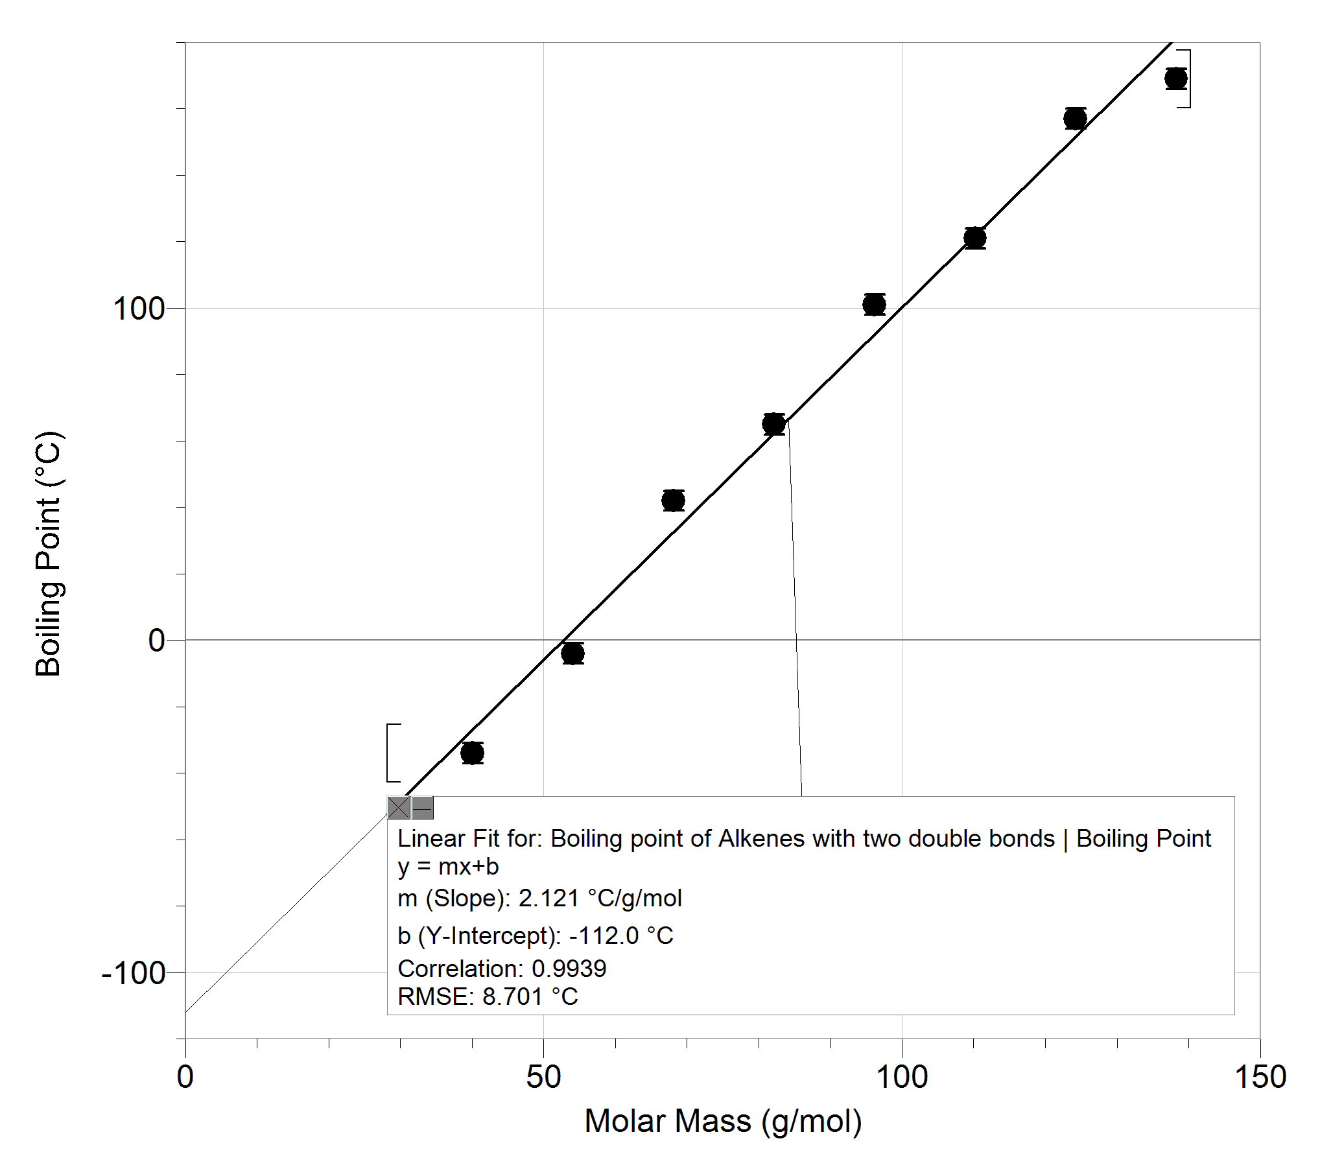

**Boiling point of Alkenes with two double bonds**

Here, we can see a more concrete trend when comparing the data above to the data for alkenes. The presence of 2 double bonds, regardless of location, creates stronger intermolecular forces which in turn makes those forces become harder to overcome. Thus, the boiling point of dienes (2 double bonds) are greater than the boiling points of alkenes.

Now we can analyze the impact of chaining and branching on alkanes and alkenes. To do this, we will add a methyl and if possible, an ethyl chain on all of our compounds. Note, some of the compounds below did not have database information for them, thus a boiling point predictor tool was used whose average error margin was 40 degrees as indicated by the uncertainty.

**Boiling Point for Hydrocarbons with methyl and ethyl chaining**

| **Hydrocarbon Chemical Name** | **Molar Mass (g/mol)** | **Boiling Point( ± 3.0 °C)** |
| --- | --- | --- |
| **2-methylpropene** | 56.11 | -6.9 |
| **2-methylpropane** | 58.12 | -12 |
| **2-methylbutene** | 70.13 | 31.2 |
| **2-methylbutane** | 72.15 | 28 |
| **2-ethylbutene** | 84.16 | 65 |
| **2-methylpentene** | 84.16 | 62 |
| **2-methylpentane** | 86.18 | 60 |
| **2-ethylpentene** | 98.19 | 60 |
| **2-methylhexene** | 98.19 | 92 |
| **2-methylhexane** | 100.20 | 90 |
| **2-ethylhexene** | 112.21 | 120 |
| **2-methylheptene** | 112.21 | 120 |
| **2-methylheptane** | 114.23 | 116 |
| **2-ethylheptene** | 126.24 | 183 +/- 40 |
| **2-methyloctene** | 126.24 | 183 +/- 40 |
| **2-methyloctane** | 128.25 | 143 |
| **2-ethyloctene** | 140.27 | 184 +/- 40 |
| **2-methylnonene** | 140.27 | 184 +/- 40 |
| **2-methylnonane** | 142.28 | 169 |
| **2-ethylnonene** | 154.29 | 192 +/- 40 |
| **2-methyldecene** | 154.29 | 192 +/- 40 |
| **2-methyldecane** | 156.31 | 189 |
| **2-ethyldecene** | 168.32 | 216 |

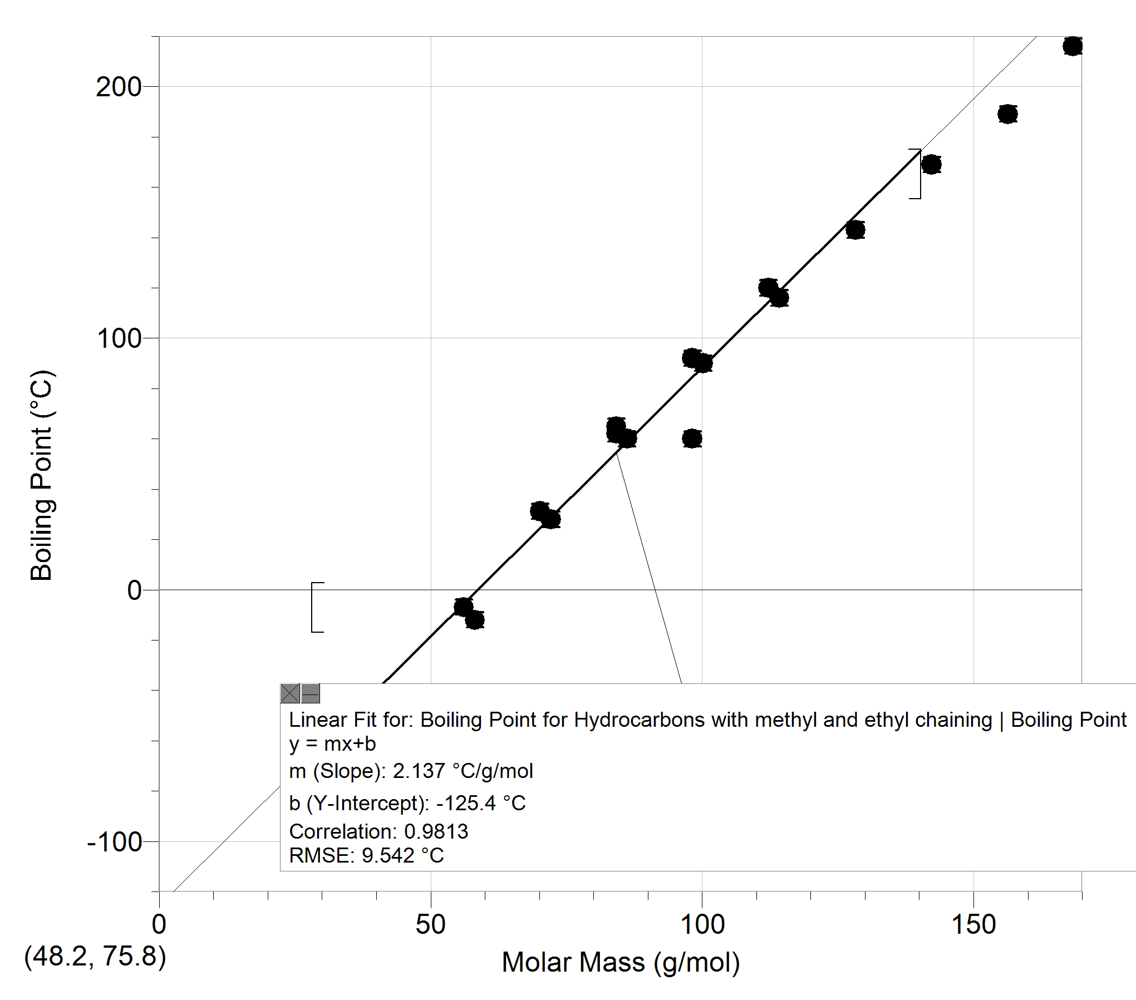

**Boiling Point for Hydrocarbons with methyl and ethyl chaining**

Here, we can also see a relatively strong trend compared to the boiling points of simple alkenes and alkenes. When an ethyl or methyl chain is added onto the hydrocarbon chain, the boiling point increases since there are more carbons and hydrogens present in the chain. In hindsight, there were a lot of compounds that were identical in molar mass and boiling point simply because they had the exact same number of carbons and hydrogen atoms. For example, 2-ethyloctene and 2-methylnonane both had a molar mass of 140.27 with a boiling point of 183 +/- 40. All in all, the presence of extra carbon and hydrogen atoms cause a higher boiling point.

**Evaluation**

From the data collected the following can be summarized:

* The presence of extra Carbon and Hydrogens creates more intermolecular forces causing an increase in boiling point.
* The lack of hydrogens in alkenes make them slightly weaker and easier to boil than alkanes.
* The single bonded carbon and hydrogen bonds on the outer parts of the chain serve as shielding for the stronger double bond. So centralized double bonds are slightly stronger
* The presence of 2 double bonds, regardless of location, creates stronger intermolecular forces which in turn makes those forces become harder to overcome. Thus, the boiling point of dienes (2 double bonds) are greater than the boiling points of alkenes.

All in all,

Boiling point from lowest to highest:

Alkenes < Alkenes with centralized double bond < Alkanes < Dienes < Chained Hydrocarbons

From this data, we can derive a number of facts that allow an understanding of which materials may be effective for which purposes. However, before this, the understanding of the differences in some other notable chemical properties should be considered. Primarily, alkenes are unsaturated compounds and because of the presence of a double bond, they are unable to completely combust in oxygen. Also, the pi bonding due to the presence of a double bond within alkenes causes them to be more reactive than alkanes whose single bonds host only a sigma bond.[7]

Given the data and these facts, we can notice how alkanes would make the perfect fuel, as they are relatively easy to combust and are not much harder to boil than alkenes. Alkanes such as ethane, propane, butane and octane are commonly used as fuels for engines of all types of transportations. However, alkenes would have been better fuels due to their slightly lower boiling point which would therefore demand less energy to combust, since engines utilize sparks to combust fuel to the flash point where they instantaneously ignite. However, alkenes are unable to hold complete combustion reactions in oxygen, and thus cannot be utilized as fuels. However, this characteristic of alkenes makes them ideal for materials such as plastics, polymers, lacquers and fibers. Namely, the most important and commonly used alkenes in the materials and chemical industries are ethene (ethylene), propene, and 1,3-butadiene. In our data, we witnessed dienes to be stronger in general than the rest of the alkenes, which is why their pattern of alternating double bonds would make them perfect for materials, which is in fact exactly what they are used for.

**Conclusion**

Given the data provided throughout this IA, the hypothesis has been observed to be partially correct. For the case of alkenes, alkanes, centralized alkenes and hydrocarbon chains, as the number of Carbon and Hydrogen atoms increased the boiling point did as well, and it was due to the increased intermolecular attractions that this happened. However, a unique scenario was the dienes. Here, they actually had larger boiling points than both alkenes and alkanes, although their molar mass was smaller. This was due to the fact that their extra strong double bond made up for the hydrogen deficiency within the compound. However, aside from dienes, the trend laid out by the hypothesis was observed in all graphs, which depicted a strong positive correlation between molar mass and boiling point.

**Limitations and Improvements**

|  |  |  |  |
| --- | --- | --- | --- |
| **Issue** | **Correction** | **Impact on Results** | **Type** |
| Choice of compound was limited to strictly hydrocarbons | For future inquiries, expand the inquiry question and investigate the impacts that other functional groups, such as esters, ethers, aldehydes, ketones or alcohols may have on their boiling point | Out of the three intermolecular forces that could’ve been observed, only london dispersion forces were open to inquiry, while the implications of hydrogen bonding or dipole dipole forces had a lot more room for investigation, | Systematic |
| Prohibition of in person experiments | Conduct experiments at home before writing the IA | One of the largest limitations to the creation of the IA was the fact that we were not allowed to conduct in person experiments, and in turn limited us from having qualitative analysis and an overall understanding of the concepts with our own eyes. | Random |
| Lack of verification using formulae | Conducting calculations based of the experiments conducted at home | Since the experiment was done using a database, theoretical calculations for boiling point itself were unable to happen accurately since the methodology of the databases were not given. | Systematic |
| Sample Size | Possibly utilize the line of best fits created to predict the properties of carbon chains longer than 10 | Many important hydrocarbons such as dodecane were unable to be used due to the restriction of hydrocarbons up to 10 Carbons. | Systematic |

**Works Cited**

*ChemSpider | Search and share chemistry*, http://www.chemspider.com/. Accessed 19 January 2023.

“Boiling Point Predictor.” *AAT Bioquest*, https://www.aatbio.com/tools/predictive-modeling/boiling-point-predictor. Accessed 19 January 2023.

“8.9: Uses and Sources of Alkenes.” *Chemistry LibreTexts*, 30 May 2020, https://chem.libretexts.org/Bookshelves/Organic_Chemistry/Map%3A_Organic_Chemistry_(Wade)_Complete_and_Semesters_I_and_II/Map%3A_Organic_Chemistry_(Wade)/08%3A_Structure_and_Synthesis_of_Alkenes/8.09%3A_Uses_and_Sources_of_Alkenes. Accessed 19 January 2023.

“4.12: Uses and Sources of Alkanes.” *Chemistry LibreTexts*, 13 February 2019, https://chem.libretexts.org/Courses/Sacramento_City_College/SCC%3A_Chem_420_-_Organic_Chemistry_I/Text/04%3A_Structure_and_Stereochemistry_of_Alkanes/4.12%3A_Uses_and_Sources_of_Alkanes. Accessed 19 January 2023.

“4.12: Uses and Sources of Alkanes.” *Chemistry LibreTexts*, 13 February 2019, https://chem.libretexts.org/Courses/Sacramento_City_College/SCC%3A_Chem_420_-_Organic_Chemistry_I/Text/04%3A_Structure_and_Stereochemistry_of_Alkanes/4.12%3A_Uses_and_Sources_of_Alkanes. Accessed 19 January 2023.

“Hydrocarbon.” *Wikipedia*, https://en.wikipedia.org/wiki/Hydrocarbon. Accessed 19 January 2023.

“Hydrocarbons - Physical Data.” *The Engineering ToolBox*, https://www.engineeringtoolbox.com/hydrocarbon-boiling-melting-flash-autoignition-point-density-gravity-molweight-d_1966.html. Accessed 19 January 2023.

“In general, alkenes are not used as common fuels.” *Byjus*, https://byjus.com/question-answer/in-general-alkenes-are-not-used-as-common-fuels-true-false-1/. Accessed 19 January 2023.

“Propadiene.” *Wikipedia*, https://en.wikipedia.org/wiki/Propadiene. Accessed 19 January 2023.

“Reactivity of Alkenes.” *Chemistry LibreTexts*, 12 September 2020, https://chem.libretexts.org/Bookshelves/Organic_Chemistry/Supplemental_Modules_(Organic_Chemistry)/Alkenes/Reactivity_of_Alkenes. Accessed 19 January 2023.

Boiling, https://www.chem.purdue.edu/gchelp/liquids/boil.html. Accessed 19 January 2023.

“Safety Data Sheet: Hydrocarbons, C5-C6, n-alkanes, isoalkanes, <5% n-hexane.” DHC Solvent Chemie GmbH, 13 October 2017, https://www.dhc-solvent.de/files/dhc/download/DHC_SDS_008_en.pdf. Accessed 19 January 2023.

“Intermolecular Forces and Boiling Points.” LibreTexts, https://chem.libretexts.org/Bookshelves/Organic_Chemistry/Map%3A_Organic_Chemistry_(Wade)_Complete_and_Semesters_I_and_II/Map%3A_Organic_Chemistry_(Wade)/02%3A_Structure_and_Properties_of_Organic_Molecules/2.11%3A_Intermolecular_Forces_and_Relative_Boiling. Accessed 19 January 2023.

1. “Hydrocarbon.” *Wikipedia*, https://en.wikipedia.org/wiki/Hydrocarbon. Accessed 19 January 2023.
2. “4.12: Uses and Sources of Alkanes.” *Chemistry LibreTexts*, 13 February 2019, https://chem.libretexts.org/Courses/Sacramento_City_College/SCC%3A_Chem_420_-_Organic_Chemistry_I/Text/04%3A_Structure_and_Stereochemistry_of_Alkanes/4.12%3A_Uses_and_Sources_of_Alkanes. Accessed 19 January 2023.
3. *Boiling*, https://www.chem.purdue.edu/gchelp/liquids/boil.html. Accessed 19 January 2023.
4. 4 “Safety Data Sheet: Hydrocarbons, C5-C6, n-alkanes, isoalkanes, <5% n-hexane.” *DHC Solvent Chemie GmbH*, 13 October 2017, https://www.dhc-solvent.de/files/dhc/download/DHC_SDS_008_en.pdf. Accessed 19 January 2023.
5. “Hydrocarbon.” *Wikipedia*, https://en.wikipedia.org/wiki/Hydrocarbon. Accessed 19 January 2023.
6. 6 “Intermolecular Forces and Boiling Points.” LibreTexts, https://chem.libretexts.org/Bookshelves/Organic_Chemistry/Map%3A_Organic_Chemistry_(Wade)_Complete_and_Semesters_I_and_II/Map%3A_Organic_Chemistry_(Wade)/02%3A_Structure_and_Properties_of_Organic_Molecules/2.11%3A_Intermolecular_Forces_and_Relative_Boiling. Accessed 19 January 2023.
7. 7 “Reactivity of Alkenes.” *Chemistry LibreTexts*, 12 September 2020, https://chem.libretexts.org/Bookshelves/Organic_Chemistry/Supplemental_Modules_(Organic_Chemistry)/Alkenes/Reactivity_of_Alkenes. Accessed 19 January 2023.